Unit IV

STRINGS:

* Collection of individual array elements.
* Enclosed within double quotes.
* Always terminated by null character “\0” [imp for string length]
* syntax: char str[size]
* char city[] 🡪 compile time error
* operations on strings: #include <string.h>
* string initializations:
  + char str[50] = “Hello world”
  + char greeting[] = {“h”,”e”,”l”,”l”,”o”}
* scanf(“%s”, str); #NO & like in integers.
* A computer code with white text

  AI-generated content may be incorrect.accepts only i/p specified. Here, aeiou
* If %[^aeiou] accepts all i/p apart from specified.
* ASCII for A -Z (65 to 91) and a -z (97 to 123)
* Lower case to upper case: subtracts 32 from character.
* 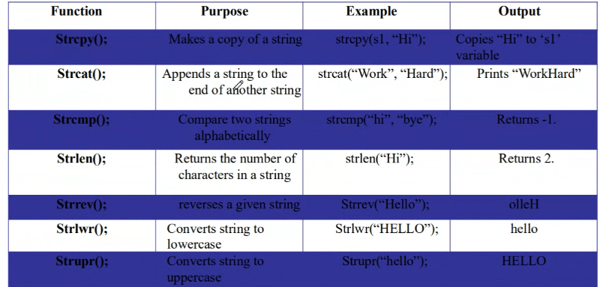
* A group of black text

  AI-generated content may be incorrect. strcmp

FUNCTIONS:

* It is a block of code that performs a specific task.
* It has a name and is reusable in different parts of the program.
* It also optionally returns a value to the calling program.
* Types of functions:
  + void function(void)
  + void function(int)
  + int function(void)
  + int function(int)

Unit V

STRUCTURES:

* Array: a user defined type stores data element of same datatype
* Structure: user defined type that can hold a collection of elements of different datatypes.
* Declaring:

struct student{

char name[20];

char usn[10];

int courses;

float marks1, marks2, marks3;

} S1, S2, S3;

* Two ways of declaring or defining a structure:
  + Tagged: starts with the keyword struct followed by tag name

* + Typedef: required an identifier ar the end of the structure block and before the semicolon.

* Structure variable syntax: struct <struct_name> var_name
* A screenshot of a computer

  AI-generated content may be incorrect.
* A screenshot of a computer program

  AI-generated content may be incorrect.
* Each structure member is allocated separate memory area.
* To access individual structure member: the structure member operator(.) aka direct selection operator
  + syntax: struct_var.member_name
* initializing a structure:A computer screen shot of a computer program

  AI-generated content may be incorrect.

POINTERS

* provides a way of accessing a variable without referring to the variable directly.
* The mechanism used for this is the address of the variable
* The prog stmt can refer to a variable indirectly using the address of the variable.
* Pointer variable stores the memory address of the variable
* Pointer holds address rather than a value thus it has 2 parts:
  + The pointer itself holds the address
  + The address points to a value
* Returns more than one value from the function indirectly.
* The pointer operator is * aka address operator.
* The value at address operator is called indirection operator.
* A computer screen shot of numbers

  AI-generated content may be incorrect.